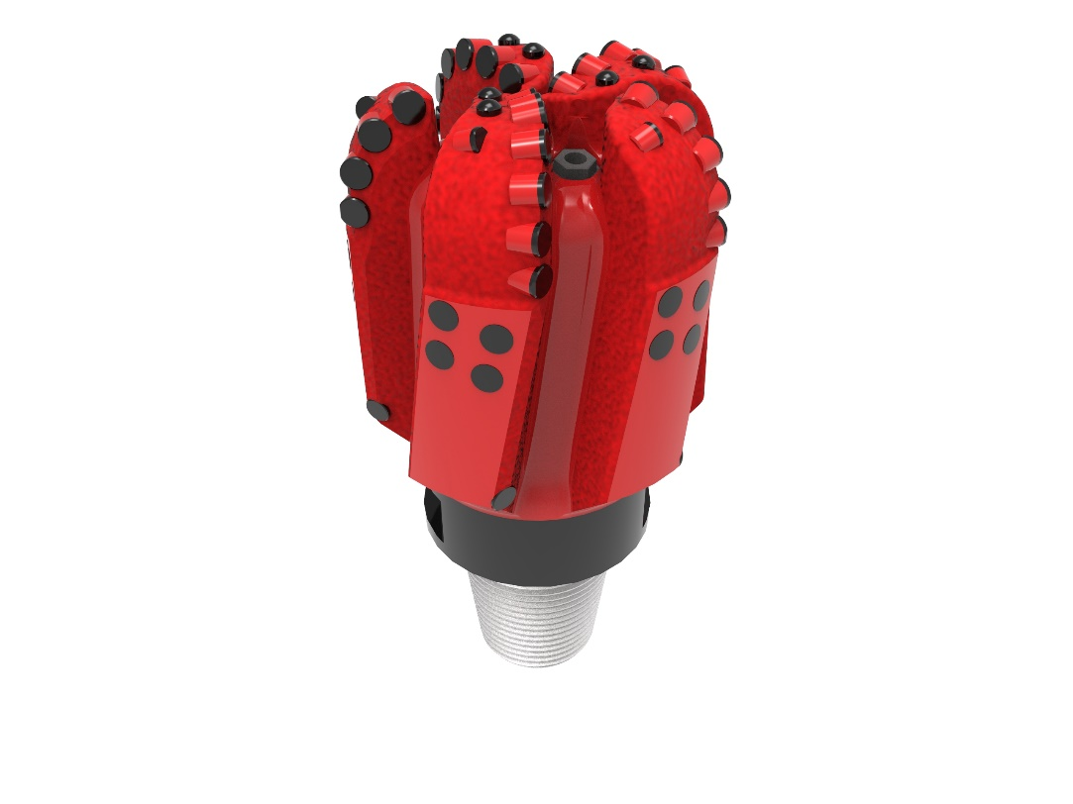
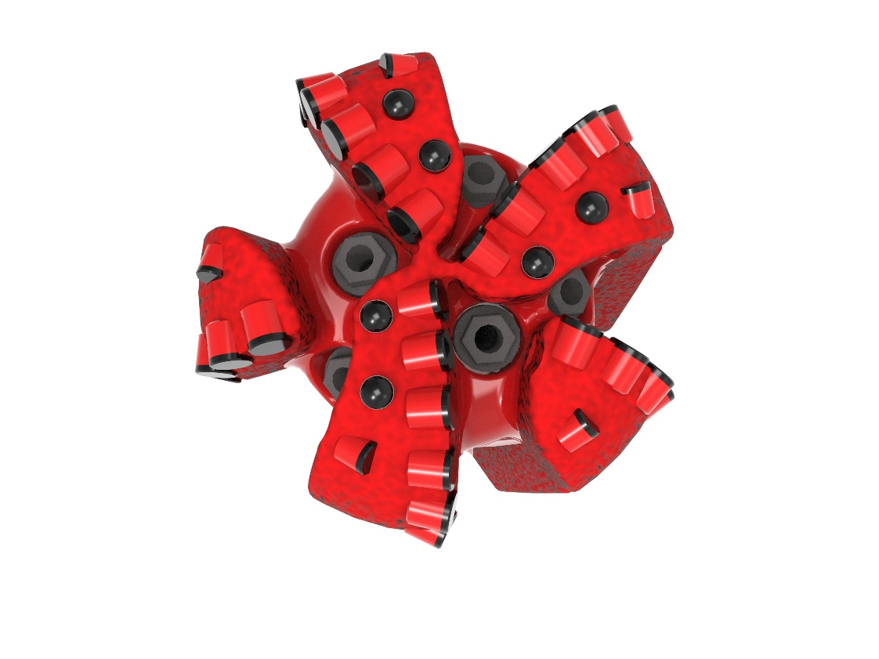

Drill Bit Specifications:
Cutter Size (Primary, Sec) | 1/2”,7/16”
Cutter Count (Total,Gage,Back Ream) | 39,5,5
Blade Count | 5
Gage Length (Inches) | 4.00
Nozzle Count (Primary, Sec.) | 5
Nozzle Series (Primary, Sec.) | 55
JSA (Sq. Inches) | 9.57
Max. TFA (Sq. Inches) | 0.98
Operating Parameters:
Max. Weight on Bit (1,000 Lbs.) | 28
Make-up Torque (ft/lbs) | 7,611
Nominal Dimensions:
Overall Length (Inches) | 13.22
Make Up Length (Inches) | 9.47
Bit Breaker | SKB-21012
Connection | Ø3-1/2" API Reg.
Approx. Weight (Lbs.) | 60

Tailor-Made Features:

- Premium grade cutters maximize ROP and Life

- Customized gauge design: 4” total gauge length - 1” full, 3” tapered @ 0.8°

- Nozzle configuration and large open face volume optimize blade cleaning and cuttings removal

513-XR(K)(BR) Nomenclature Explained:

• | 5 | = | Number of Blades
• | 13 | = | Primary Cutter Size (13mm)
• | XR+ | = | Backup Cutters
• | K | = | Bullets
• | BR | = | Back Reaming Cutters


